How to create a questionnaire in Word using forms fields.

- Turn on the Forms toolbar.

View | Toolbars Forms

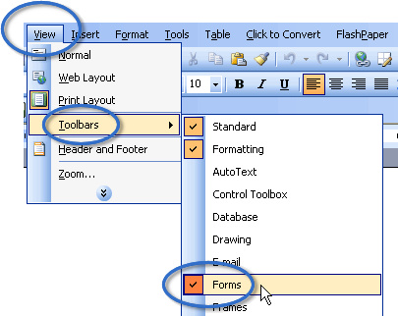

- Using Check boxes
Insert the text for the question.

Please select your gender:
Male Female Intergender Transgender

(Note although most questionnaires only provide 2 gender choices there are many hundreds of thousands of people in the world who do not fit comfortably with either gender. Or who have changed their gender.)

See:
http://en.wikipedia.org/wiki/Intergender

http://en.wikipedia.org/wiki/Transgender

3) Insert a check box fields using the Forms toolbar
Male Female Intergender Transgender

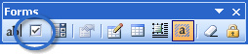

4) Using a Drop-Down form field
Insert your question and place the cursor where you want the drop-down
field to appear.

5) click on the Drop-Down Form Field tool

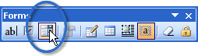

6) It is a good idea to turn on Form Field Shading

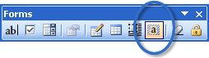

7) Double click on the field this should open up the Drop-Down Form Field
Options dialogue box.

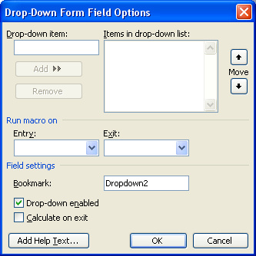

Note: it’s advisable to make the first entry in the Items drop-down list an instruction to make a selection. That way if the user forgets to make a selection you will know. Otherwise you’re likely to skew your data with the default choice appearing when no choice was made.

8) Enter the instruction to make a selection in the Drop-down Item: field:

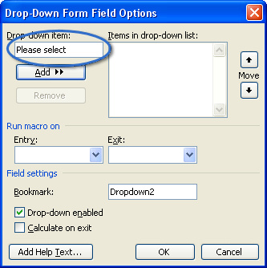

9) Click Add >>

10) Repeat this process to enter each choice and click OK

Note: if you want to reorder your items select the item that you wish to move and use the Move buttons to move it up or down the list.

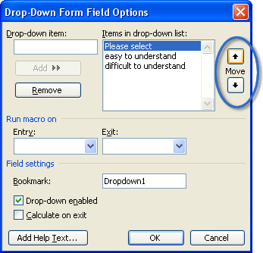

These instructions on creating forms are:

11) To test the form you must protect the form click on the Protect Form tool
in the Forms toolbar

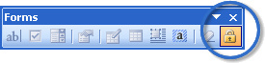

Note: If you want to continue to add more questions you must unlock the
form.

12) Before you distribute the form you may want to Reset the form fields and Protect the Form

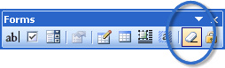
13) Save the form document as a Document Template.
Note: don’t call the file Normal.dot or Word will not work properly next
time you start it.

File | Save As… | Save type as: | Document Template (*.dot)

Saving the file as a Document Template will create a fresh document each time you open the Template file.

See also:
http://cc.dasnr.okstate.edu/ccfiles/Creating_forms_in_MSWord2003.doc

